Control Systems Lab Name:________________

Prelab 2: In-Class Assignment RIN: ________________
- What is the INPUT and what is the OUTPUT for the DC motor transfer function derived in class?

Input: Output:

For Questions 2,4,5,6, assume the given parameters below for the DC motor:
R = 7.22 Ω  k_{b}= 0.0154 V·s/rad  k_{t}= 0.0154 N·m/A | J_{eq}= 2.28e-6 = 0.00000228 kg·m²  b = 0 N·m/rad/sec (damping/friction neglected)  $ω_{max}=270 rad/sec$

- Compute the expected time constant, $τ$, and steady state gain, $K$, of the DC motor. Include units.

- Assume a time constant, $τ=0.1$ seconds, and steady state gain, $K=50\frac{rad}{s∙V}$. Sketch the expected response of the rotation speed to an input voltage of 3.5V from zero volts. Include quantitative labels on the axes. (this problem does not need the parameters given above)
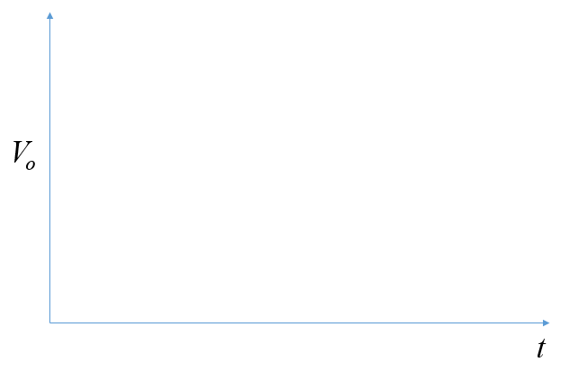
ω

In Questions 4,5, and 6 consider a multimeter range that cannot measure higher than 500mA.

- Use the STEADY STATE electrical equation to solve for the input voltage that corresponds to a maximum measurable current of 500 mA while “stalling” the motor (forcing $ω=0$).

- Will the current exceed 500 mA when the motor is free-spinning at the max speed (at voltage 5volts)? Prove your answer.

- Now you are aware of three physical limitations that must be considered in designing the experiments
  - Maximum input voltage due to saturation (discussed in the lecture)
  - Minimum input voltage due to static friction (discussed in the lecture)
  - Voltage corresponding to a current that exceeds the multimeter range limit during STALL

Considering these constraints, determine an appropriate set of Input Voltages below. Remember that testing the largest range of operating points possible is typically better for accurate estimations.

Input Voltages for experiment with motor “stalled” |  | Input Voltages for experiment with motor spinning freely

